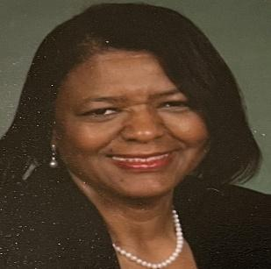

Jessie Green
Jessie Green is a retired Budget Analyst who served the Department of Defense U.S. Army for 38 years. She has an associate degree from the Atlanta Business College in Atlanta Georgia and a Bachelor of Art degree in Christian studies and Business from Grand Canyon University. She is married to the late Jerry Green they have three daughters, 10 grandchildren and 4 great grandchildren. She founded the Afri-Female Institute in 1998 with the sole purpose of addressing the long-range needs of at-risk youth and their families. Jessie has many years of leadership roles in nonprofits and government. She was enrolled in many leadership courses throughout her career, elected official for the Willingboro Board of Education (nine years). Founded an organization to improve education and mentor at risk children. Hired clerks and solicited professional volunteers for workshops to address the needs of disabled, low-income, at risk teens. Currently, Jessie serves on the Board of Director for DIMH where she volunteers at the Resource Center for Homeless Men. Jessie Joined the Rancocas Valley Chapter of Links in Willingboro NJ in 2003 and later joined the Dover Delaware Chapter in 2007 where she currently serves as treasurer and Chaplain, and previously served as Program Director and the Service to Youth Chairperson. She is a member of the Mt. Friendship A.M.E Church in Smyrna, Delaware where she serves as the Director of the Christian Education Department, and Sunday School Superintendent. In 2016 Jessie answered the call from God and is now a licensed Evangelist in the A.M.E. Church. Evangelist Green teaches Bible Study at her church.

